Jenkins Assignment 3
Creating Jenkins master and slave and Deploying war file on slave
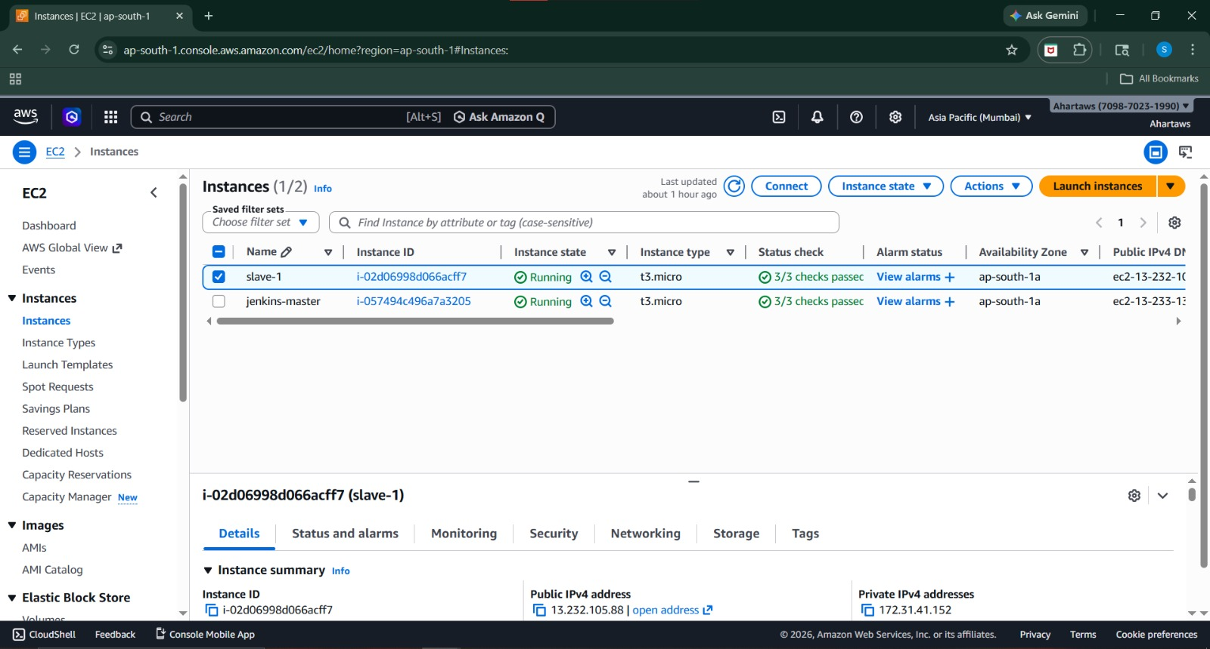
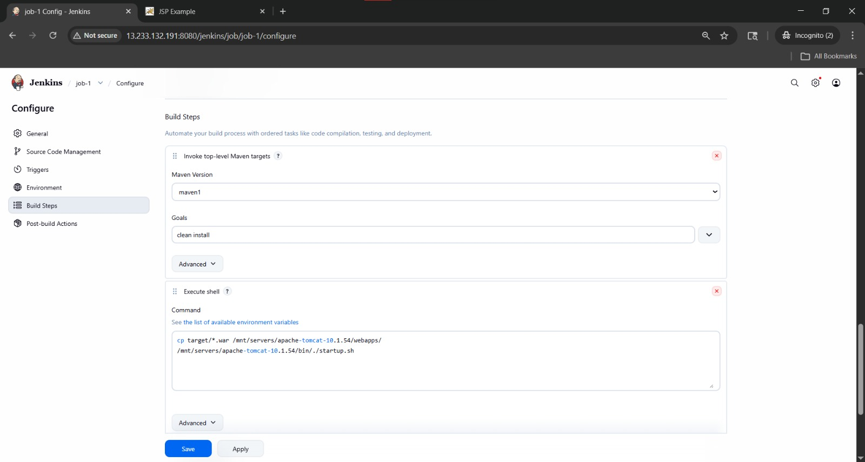
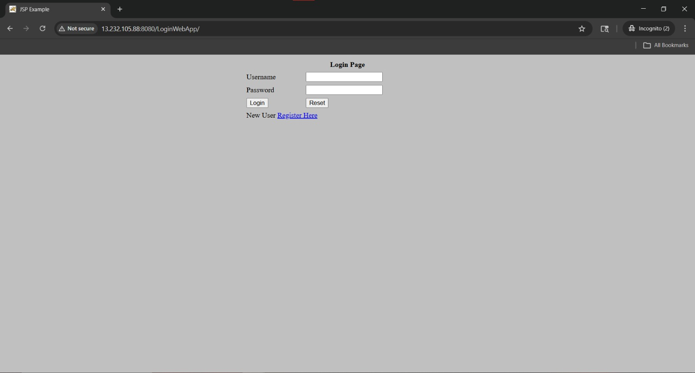

Using pipeline jobs
pipeline{
agent {
label 'slave'
}
tools{
maven 'Maven'
}
stages{
stage('clone repo'){
steps{
git branch: 'master', url: 'https://github.com/Shantanumajan6/project.git'
}
}
stage('build'){
steps{
sh 'mvn clean install'
}
}
stage('copy file'){
steps{
sh 'cp target/*.war /mnt/servers/apache-tomcat-10.1.54/webapps'
}
}
}
}
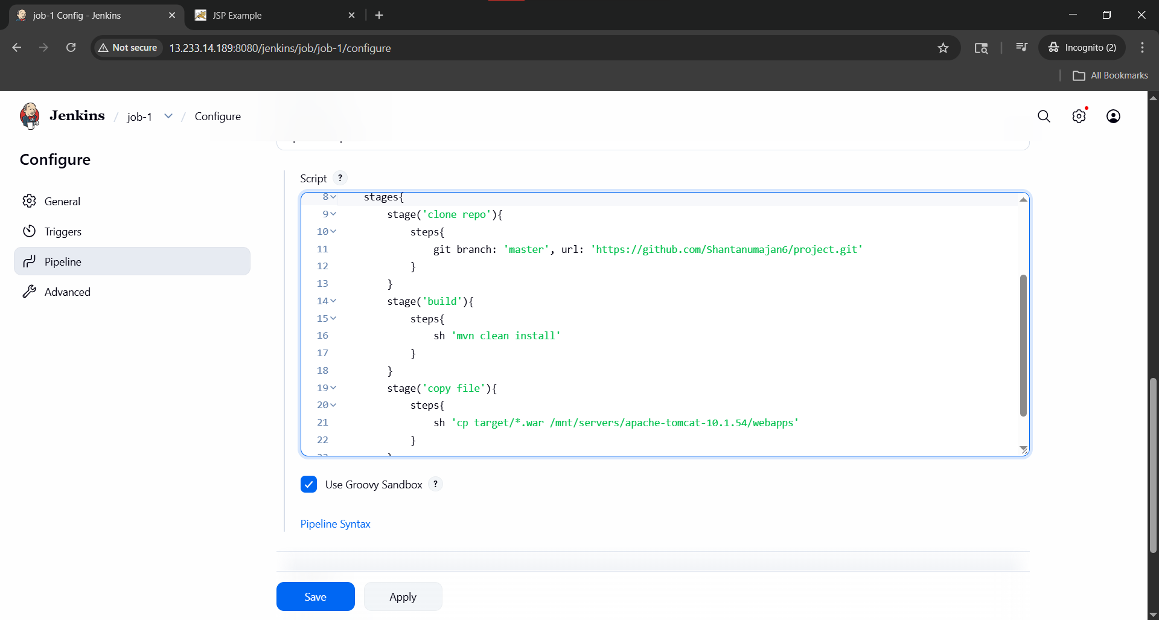
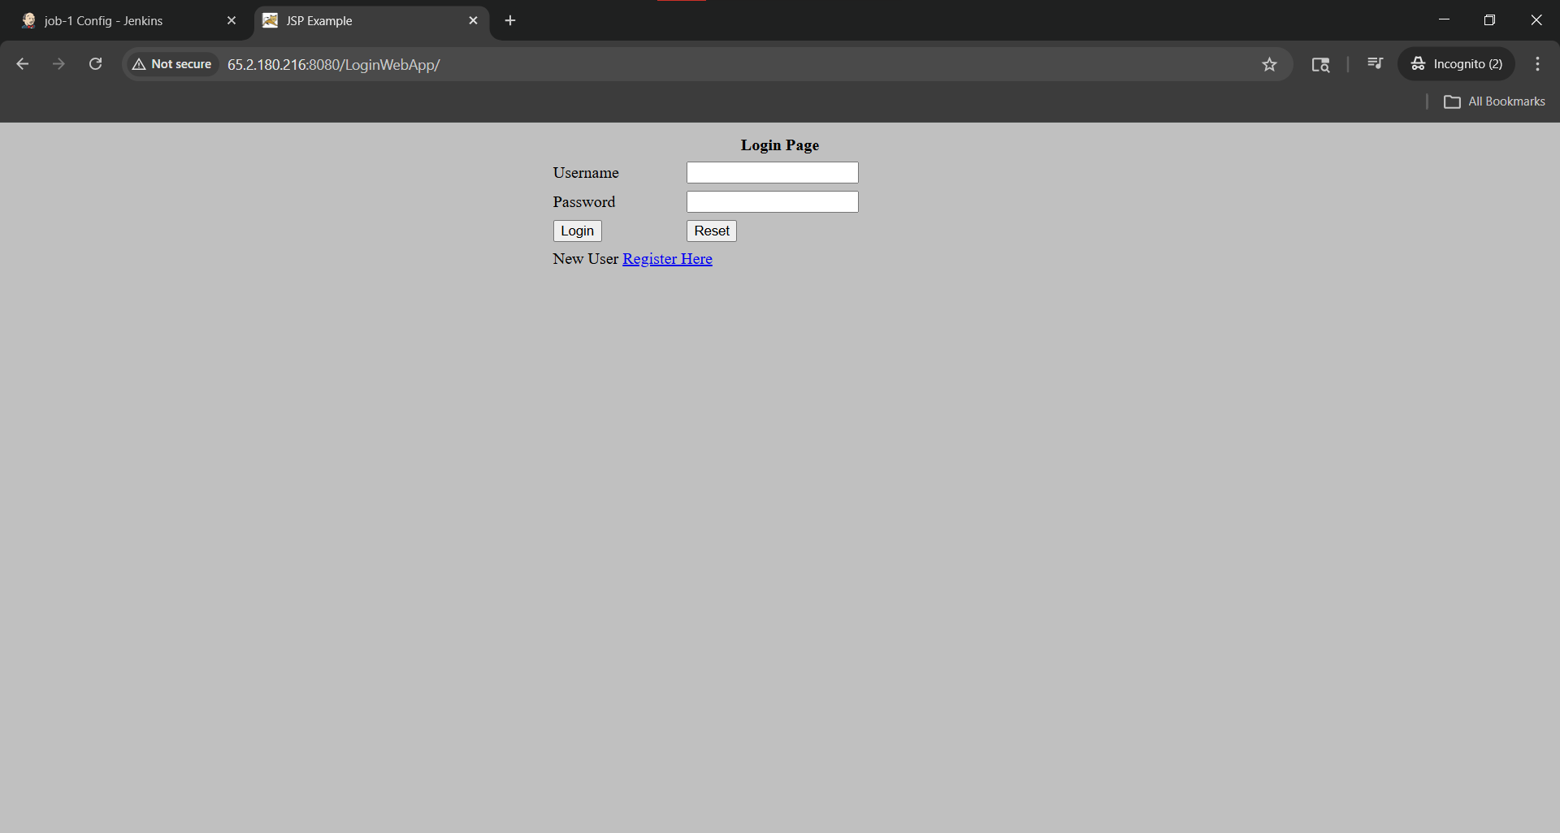

Using Jenkinsfile
pipeline{
agent {
label 'slave'
}
tools{
maven 'Maven'
}
stages{
stage('clone repo'){
steps{
git branch: 'master', url: 'https://github.com/Shantanumajan6/project.git'
}
}
stage('build'){
steps{
sh 'mvn clean install'
}
}
stage('copy file'){
steps{
sh 'cp target/*.war /mnt/servers/apache-tomcat-10.1.54/webapps'
}
}
}
}

